On a **single-threaded** CPU, we execute a program containing n functions. Each function has a unique ID between 0 and n-1.

Function calls are **stored in a** [**call stack**](https://en.wikipedia.org/wiki/Call_stack): when a function call starts, its ID is pushed onto the stack, and when a function call ends, its ID is popped off the stack. The function whose ID is at the top of the stack is **the current function being executed**. Each time a function starts or ends, we write a log with the ID, whether it started or ended, and the timestamp.

You are given a list logs, where logs[i] represents the ith log message formatted as a string "{function_id}:{"start" | "end"}:{timestamp}". For example, "0:start:3" means a function call with function ID 0 **started at the beginning** of timestamp 3, and "1:end:2" means a function call with function ID 1 **ended at the end** of timestamp 2. Note that a function can be called **multiple times, possibly recursively**.

A function's **exclusive time** is the sum of execution times for all function calls in the program. For example, if a function is called twice, one call executing for 2 time units and another call executing for 1 time unit, the **exclusive time** is 2 + 1 = 3.

Return *the* ***exclusive time*** *of each function in an array, where the value at the* ith *index represents the exclusive time for the function with ID* i.

**Example 1:**

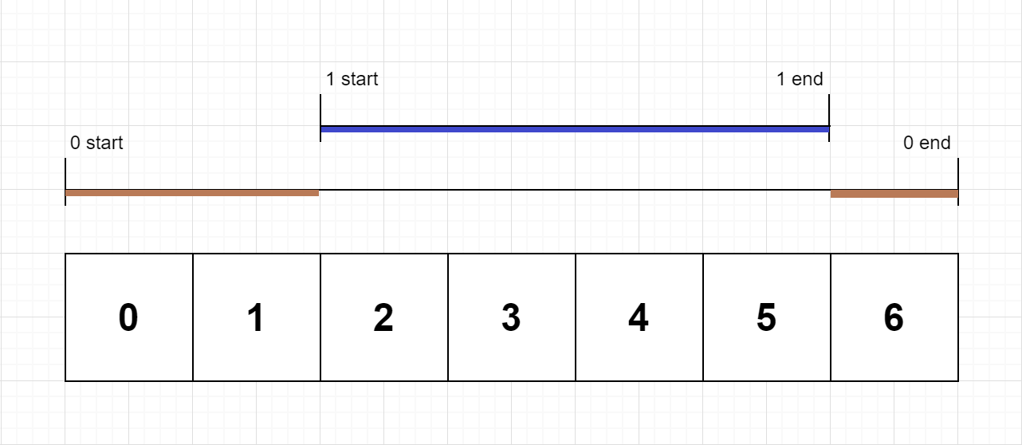

Input: n = 2, logs = ["0:start:0","1:start:2","1:end:5","0:end:6"]  
Output: [3,4]  
Explanation:  
Function 0 starts at the beginning of time 0, then it executes 2 for units of time and reaches the end of time 1.  
Function 1 starts at the beginning of time 2, executes for 4 units of time, and ends at the end of time 5.  
Function 0 resumes execution at the beginning of time 6 and executes for 1 unit of time.  
So function 0 spends 2 + 1 = 3 units of total time executing, and function 1 spends 4 units of total time executing.

**Example 2:**

Input: n = 1, logs = ["0:start:0","0:start:2","0:end:5","0:start:6","0:end:6","0:end:7"]  
Output: [8]  
Explanation:  
Function 0 starts at the beginning of time 0, executes for 2 units of time, and recursively calls itself.  
Function 0 (recursive call) starts at the beginning of time 2 and executes for 4 units of time.  
Function 0 (initial call) resumes execution then immediately calls itself again.  
Function 0 (2nd recursive call) starts at the beginning of time 6 and executes for 1 unit of time.  
Function 0 (initial call) resumes execution at the beginning of time 7 and executes for 1 unit of time.  
So function 0 spends 2 + 4 + 1 + 1 = 8 units of total time executing.

**Example 3:**

Input: n = 2, logs = ["0:start:0","0:start:2","0:end:5","1:start:6","1:end:6","0:end:7"]  
Output: [7,1]  
Explanation:  
Function 0 starts at the beginning of time 0, executes for 2 units of time, and recursively calls itself.  
Function 0 (recursive call) starts at the beginning of time 2 and executes for 4 units of time.  
Function 0 (initial call) resumes execution then immediately calls function 1.  
Function 1 starts at the beginning of time 6, executes 1 unit of time, and ends at the end of time 6.  
Function 0 resumes execution at the beginning of time 6 and executes for 2 units of time.  
So function 0 spends 2 + 4 + 1 = 7 units of total time executing, and function 1 spends 1 unit of total time executing.

**Constraints:**

* 1 <= n <= 100
* 1 <= logs.length <= 500
* 0 <= function_id < n
* 0 <= timestamp <= 109
* No two start events will happen at the same timestamp.
* No two end events will happen at the same timestamp.
* Each function has an "end" log for each "start" log.